Executive Summary
The report majors on the two processes within Saudi Electric Company. The selected processes in this report are the “Customer's Relationship Maintenance” in the company and the “Risk Management and Control” within the company. To attain the intended mission of the article, it has dramatically looked into each process into depth. The process explanation is captured for each of the process as well as the associated details such as its architecture, analysis and even the technology that is being used in each process. Besides that, the report has also offered a description of the model used in each case to make readers understand each of the models. In the end, it has given out the summary of the entire analysis as well as the associated recommendation.

Introduction
The report in this case study will look into two processes witnessed within Saudi Electricity company. The procedures selected are specifically "Customer's relation to the company" and the "control and management of risk in the company." The two processes are will mainly be viewed about the technological advancements as well as enhancement of cybersecurity within the company. To get a better understanding of the above, there will be a need to have a brief overview of the technology and the impacts it has brought in various businesses. Nevertheless, the challenges that have been imposed on the processes by the technological changes will also be discussed into depth together with the measures that the company has taken to counterfeit the challenges.

Overview of Saudi Electricity Company
Saudi Electricity Company is a Saudi electric service organization. It appreciates an imposing business model on the age, transmission, and dispersion of electrical power in Saudi Arabia through 45 control age plants in the country (Chiu et al., 2014). The organization was framed in the year 2000 by the order of committee of Ministers throughout amalgamation of accessible regional electricity companys in the Eastern, Central, Southern and Western districts into the form of private joint supply company. In the year 2009, the electrical energy and the Cogeneration Regulatory Authority (ECRA) affirmed its anticipation to the part of the association into four age firms and disconnected broadcast and circulation organizations to empower rivalry in residential utility sector (Monczka et al., 2015). A broadcast organization was built up in the year 2012 purposely to work the regional grid. In the year 2014, the ECRA was mentioned to have employed counsels on the partition of the company. Basically, the ECRA in addition confirmed the new age firms would in turn be available to foreign investment. The organization is 81.24 percent possessed by the legislature, both straightforwardly (74.31%) and throughout the Saudi Aramco that contributed to 6.93%. SEC intends to extend its capacity age limit from particularly 60 GW to about 91 GW and even more than twofold the current limit over a long haul to satisfy already existing demand.
With the above information, it is clear that it is significantly involved in offering services to the clients. In this connection, it is developing a system of right relationship with its customers. Creation of the excellent relationship entails the establishment of the mode of linking itself to the potential clients and even other individuals' worldwide (Monczka et al., 2015). The above requires the creation of the webpage for advertising its services. For its client's it also has a system that connects to them to effectively satisfy its customers as well as making sure it is there for the firm whenever the need arises.
Regarding management of the firm, it is of great importance noting that the firm is subjected to cyber insecurity as hackers are tending to intervene in the operation within the firm. Based on such, the administration team is taking an initiative to deploy a system that would keep off the hackers from their malicious activities (Harper, 2015). The above entails the installation of the system operation security tool and also practicing the safety cybersecurity practices.

Literature Review
Regarding the current situation, several organizations have been greatly affected by technological advancements. The impacts that are brought to the organization by the technological changes are mainly negative, and all businesses thus are required integrate their systems so that they may be in line with the technological change currently in the market (Monczka et al., 2015). In the view of the Saudi Electricity company, it has made an effort in the integration of its operational systems as well as networking of the departments and customers to enhance security and confidentiality of the data within the company.
Given such, it is clear that the company is striving hard to maintain a good relationship to its customers (Chiu et al., 2014). Notably, it has therefore created a system that mainly prevents customer's data from exploitation. Besides such, the company is also embracing wearable computing where the inquiry posted by the customers is received immediately through the alerts made by the wearable device (Monczka et al., 2015). Consequently, the customers stand a chance to get immediate feedback from the company. In such incidences, the clients of the company usually feel appreciated and acknowledged by the company. On the side of the company, the practice makes it retain its competitive advantages over any other growing electricity provider company all over the world.
Regarding the administration process within the company, findings show that the company is significantly investing in the administration control of the services that it offers. The process is facilitated by the centralization of the system as well as a network of monitoring the flow of electricity to its clients (Monczka et al., 2015). The above is done by computerizing the entire system where the administration quickly notices any breakdown of the flow. At the same time, the branches of the company are all linked to the central server of the company thus enabling natural trace of the activities taking place in all the departments under the first company.

Analysis of the Model, Technology

Process 1: Customer's Relationship Maintenance

The primary model that the company is using in the management of customer relationship and securing of their data is enterprise resource management. In this case, the company mainly emphasizes the resources management, financial information management and the entire operation of the company (Chiu et al., 2014). The analysis of the process is very crucial about the technological changes to ensure all the data is secure in the organization. However, it contains some associated challenges that are yet to be solved as the research would depict (Monczka et al., 2015). Therefore, there arises a need for offering recommendations on the steps that are required to maintain good relation and enhance the company's operations continuously.

Process Introduction
The business process mainly entails the management of the services offered to the clients and the control of their relationship to ensure there is an actualization of the needs of the customers. The process involves three activities that include offering services to the clients, securing their financial data subscription and also monitoring their payment details where the company is obliged to claim the payments of the services rendered to customers (Harper, 2015). In this case, the company is incorporating current technology for the effective operation of the company. The technology enables the company to tackle the mentioned practices that constitutes the specified process.

Technology in Use
The company is using a hybrid approach in discharging the required task regarding the mentioned process. Following the process keenly, the research shows that the company mainly combines the risk management model with the human resource management model to meet the mission and vision of the company (Harper, 2015). With risk management model, it is applied in the control of the flow of the electricity to all the customers whereas the human resource management is used in the synthesizing and maintenance of the relationship of the clients as well as ensuring there is complete satisfaction of their needs. The above results into the system that is as shown below
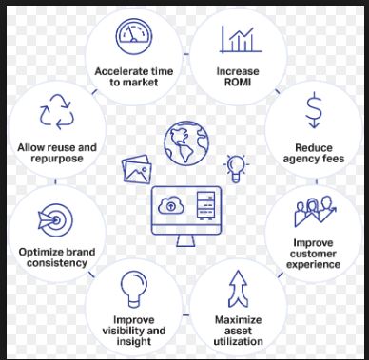
In regard to the distribution control, the company is integrating its system. At the same time, there is an application of the oracle in the company where the system is as follows
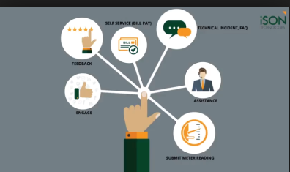

System Architecture
The system architecture used in this company in relevant to the process is as follows
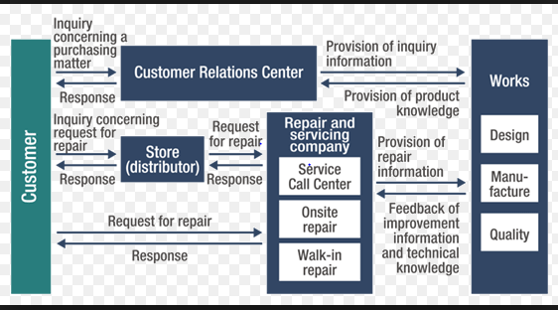
The system architecture in reference to Oracle is as shown below
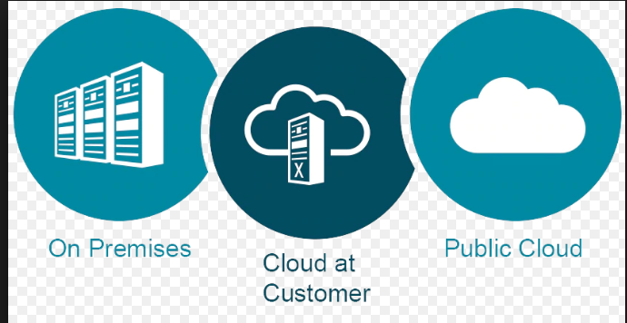

Process Explanation
The utilization of controlled electrical burdens goes for lessening the most extreme burden and recessing the expansive increments in electrical loads as experienced by Saudi Electricity Company, which represent 2,000 MW every year (Harper, 2015). To achieve this objective, SEC connected an extraordinary framework to control cooling (AC) loads amid the pinnacle time frame in the mid-year of 1995, which keep running from Saturday through Thursday from noon-early afternoon to 5:00 pm, amid the long periods of May to September. This framework speaks to an immediate intercession in electricity offices to control and decrease AC loads and eventually lessens the pinnacle load in the electrical system. The organization is connected to this framework to monitor the activity of AC frameworks of real clients, and decrease their heaps at various rates amid pinnacle request referenced before (Monczka et al., 2015). This framework incorporates all focal AC chillers (substantial coolers), split sort units, and coordinated AC frameworks, control frameworks and transfers (Chiu et al., 2014). It likewise incorporates the establishment of shipments, cooling control and correspondence frameworks at the client's area. In this worry, SEC gives every single required control and hardware for this framework, notwithstanding their activity and maintenance. SEC's contractual workers and advisors introduce this gear at the client's area and affirm the operational wellbeing of the AC frameworks.
This seat adds to reinforcing the organization among SEC and the college through advantages accomplished for the Kingdom including:
- Improving request anticipating.
- Surveying powers’ framework dependability.
- Acquainting upgrades with improving control framework security.
- Improving SEC client’s nature of administration.
- Limiting deficiencies and interferences, upgrading framework wellbeing and unwavering quality.
- Incrementing logical advantages to SEC and its staff.
In addition, the chose clients to this framework are required to do the accompanying:
- Cooperating with the organization to convey this undertaking to progress.
- Writing assent permitting the utilization of this framework on all introduced AC frameworks and units in client's offices.
- Allowing passage of temporary workers and experts of the Company to areas of the AC frameworks and their adornments in the structure to introduce framework gadgets, perform electrical associations with electrical system and inside correspondences of the client. On top of such, they are keeping an eye on these gadgets at whatever point required.
Owing to the above information, the system architecture interface that is created is as follows
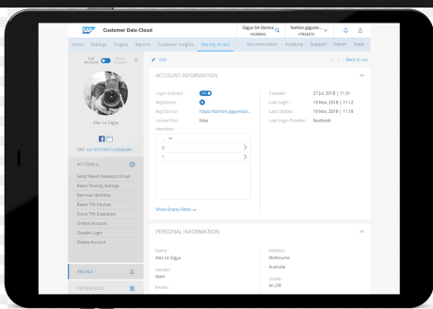
For the enhancement of the satisfaction of the customer’s needs, the following architecture interface that is embraced due to the application of wearable computing is as follows
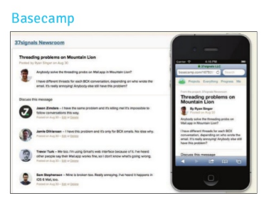

The Process Workflow
Saudi Electricity's clients expect a similar involvement with its administrations paying little respect to where the association happens via web-based networking media, on the web, coming up, on your versatile application, on your site, or through the call focus (Chiu et al., 2014). In situations where the company misses the mark concerning these desires, clients are inclined to effortlessly bounce to any number of better alternatives, putting the business in danger (Harper, 2015). Notwithstanding, the above is with negligible rates since the company is for a long time working in an imposing business model market (Monczka et al., 2015). Prophet CX Cloud Suite enables the organization to use the client experience to separate advances and improves business results. It is the most total, coordinated, and extensible client experience arrangement accessible in the market.
Prophet CX Cloud Suite separates storehouses to convey a consistent client experience crosswise over showcasing, deals, trade, administration, social, and arrange cost, and statement (CPQ). Regardless of whether conveyed separately to handle specific business challenges or sent as an exhaustive arrangement, Oracle's methodology empowers the organization to:
- Provide cross-channel, predictable client encounters utilizing pre-assembled business forms that range storehouses
- Integrate CX with big business applications, giving associations all through the purchaser's voyage and making activities progressively effective
- Leverage industry-explicit prescribed procedures for upper hand and lower TCO
- Addition quicker, more profound, increasingly exact bits of knowledge from social
- Rapidly convey substance to the perfect individuals at the ideal time
- Drive more grounded client bonds by sending proactive social client administration
- Drive quicker development through social client distinguishing proof and focusing on
The above results into the workflow that is as follows
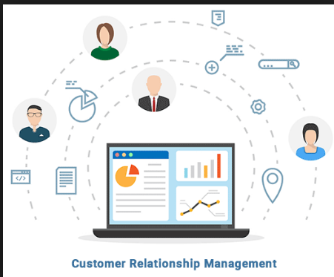

Process Analysis
In this kind of situation, the clients of Saudi electricity company are continually sharing their perspectives about what they need and long for, what they like and loathe, and what makes a difference most to them (Monczka et al., 2015). It tunes in to their clients are offer better items, make more focuses on informing, giving better client administration and figuring out how to best draw in with the correct clients in the ideal spot at the perfect time. For advertisers, the difficulties related to accessing noteworthy bits of knowledge at scale to drive client commitment are overwhelming.
Meanwhile, Saudi Electricity is implementing the SMART GRC suite for hazard the board, review, and appraisal, review issues following and consistency the board (Chiu et al., 2014). With SMART, SEC group can upgrade the interior review group's efficiency by empowering it to bind together and break down entomb departmental review information, rapidly and proficiently (Harper, 2015). Shrewd GRC stage computerized work related to the documentation and announcing of the hazard the executives and consistency exercises.

Advantages
- No more report or spreadsheets are presently fundamental, to design and advise clients.
- Having an ordinary review date-book has diminished time to plan discussion with a focal storehouse of review questions, which decreased organization work also, cost to produce review registration and review reports.
- Executing a shut circle review cycle for account discoveries, creating proposals, and actualizing activity plans.
- Giving 360-degree permeability into review procedures and measurements for better chance administration and administrative consistency.
- Having the capacity to perform appraisals, distinguish issues and oversee activities legitimately from the field on cell phones or tablets.
- Mechanization of activities, warnings and work processes to guarantee constant consistency
- Having prepared to utilize reports and dashboards, with an extra custom report
- The above has resulted in the following workflow process
The above has resulted into the following workflow process
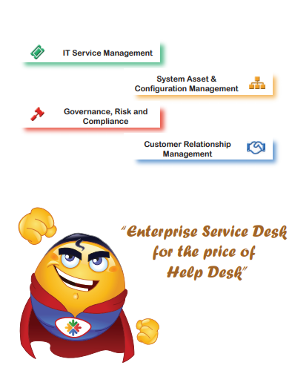

Process 2: Risk Management and Control
The process involves effective networking systems that are intended to monitor all the operations within the company (Harper, 2015). The networking system usually embraces both the internal and external connection of the elements forming up the company. The above involves both the linking to the customers that the company portrays as well as the link that is witnessed within the company (Chiu et al., 2014). The analysis of the system used in the company is elaborated in the section below.

Process Introduction
The process mainly uses the enterprise risk management model to prevent the organization from cyber insecurity risks. The process comprises of different activities that entail
- Protection of the company's records concerning the supply of the services.
- Protection of the client's data and information in order to prevent cyber-attacks of the customer's finances as well as services rendered to them.
- Protection of the employees' data to ensure their confidentiality is maintained within the company.

Technology in Use
Concerning the Saudi Electricity company, the power utilities are undeniably more helpless against cyber-attack than previously (Chiu et al., 2014). There is much interconnected computerized framework that empowers constant permeability into power blackouts hence giving the clients a chance to oversee power utilization from their cell phones and send advanced devices for vitality the executives (Harper, 2015). It is then implied that utilities are increasingly uncovered because offering these highlights over the web will require availability between utilities' previously independent operational frameworks and their IT systems.
Utilities, therefore, act ultimately to limit this hazard, yet various difficulties influence their capacity to do as such (Monczka et al., 2015). These difficulties incorporate persistently advancing business and innovation prerequisites, an across the board deficiency of qualified faculty, other dangers related with outsider connections, and the need to empower cooperation of the whole workforce in overseeing cybersecurity dangers (Niazi et al., 2016). The size of these difficulties enhancement for little utilities, which come up short on the scale and assets of their more prominent friends are attained.
The electric utility industry and governments worldwide have found a way to address the difficulties (Harper, 2015). In this case, utilities are making use of government assets, share exercises learned, train and coach more celebrated cybersecurity experts together with making cybersecurity a business, not only a specialized but also necessary. Building a culture that bolsters and supports cybersecurity is a top need that is in the mentioned company. Therefore, there is an integrated system that works to minimize the incidence of the cybersecurity attacks within the company. The system is as shown below
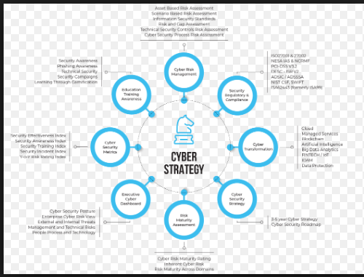

System Architecture
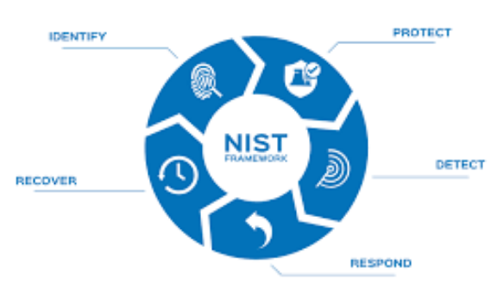

System Explanation
Electric utilities are being constrained to associate and enable information to stream between their current IT and operational-innovation (OT) systems (Paluch & Wünderlich, 2016). While IT frameworks are thought of as office frameworks, OT frameworks control the gear that plays out the utility's central goal, producing and circulating control over immense regions (Harper, 2015). These OT frameworks were once independent, and their dark restrictive conventions made it hard to access or control them from the outside world. In recent decades, in any case, the developing interest for OT-created information to give arranging, anticipating, charging, client administration and different business-basic data to various pieces of the business and clients has required more prominent network among OT and IT frameworks.
With such vast numbers of gadgets connected to the system, its assault surface is exponentially more noteworthy also: more devices mean more vulnerabilities and increasingly conceivable purposes of section (Paluch & Wünderlich, 2016). Also, cyber-warfare deviates: assailants are succeeding if they find even a solitary exploitable shortcoming, though protectors must shield all purposes of access from each conceivable assault. In this case, the threat modeling process is as follows.
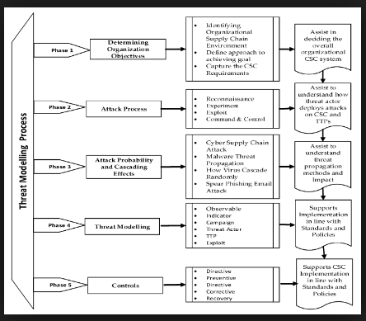

Process workflow
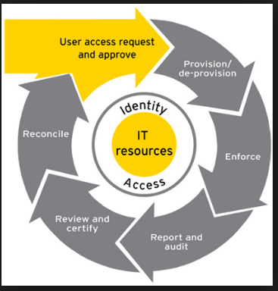

Process Analysis
Similarly, as with any digital hazard moderation plan, it is critical for Saudi Electricity company to bring in the electric power segment to approach the issue deliberately. The objective is to be secure, watchful, and versatile by creating top to bottom avoidance, discovery, and reaction plans (Chiu et al., 2014). One of the main approaches to start is to adopt the thought process of a programmer, taking into account which should need to assault the association, what is spurring them (taking information, upsetting activities, devastating resources), and how the performing artists could approach accomplishing their destinations. Even though it is difficult to shield each advantage completely, IT and cybersecurity pioneers are decided the no doubt and harming situations and spotlight their restricted assets on those (Monczka et al., 2015). Some critical strides in building up a successful digital affirmation program that will be incorporated in the company include:
- Putting a senior official in control: Numerous organizations have made a digital board of C-level officials entrusted with digital hazard administration.
- Distinguishing dangers and outcomes: Situation examination reveals the conceivable risks, for example, the robbery of client data that could influence PCI consistency or the utilization of malware to bring down a part of the power network.
- Organizing situations: IT and business pioneers would then be able to assess the recurrence and effect of every risk just as the viability of current controls. Mapping dangers to the business resources that issue are help organizations center their endeavors on the best vulnerabilities.
- Plotting situations onto the corporate hazard network: IT and cybersecurity pioneers are utilize existing corporate instruments, for example, hazard networks, to raise the cybersecurity issue to the official and board level with the goal that top administration comprehends the results and speculation required.
- Tending to conduct change: CIOs and CISOs are doing everything right, except if business clients do not modify their methods to relieve digital hazard, cybersecurity plans will probably be insufficient. Handling occasional studies to gauge the social fitness for secure practices are enlighten territories where progressively successful correspondence and preparing plans are required.
- Sustaining the inventory network: Vitality organizations are just as secure as their weakest seller interface. IT pioneers are ensured they comprehend the development and security procedures of their merchants and incorporate cybersecurity principles into obtainment forms.
- Executing the constant investigation and perception: Similarly that monetary detailing is advancing from in reverse looking static reports to ongoing examination, regularly updated announcing of digital dangers will probably before long become the standard. Digital confirmation arranging and execution is a continuous obligation. Cautious IT and cybersecurity pioneers will audit the risk scene quarterly and update their techniques, at any rate, every year to keep up importance as the scene and administrative prerequisites change.
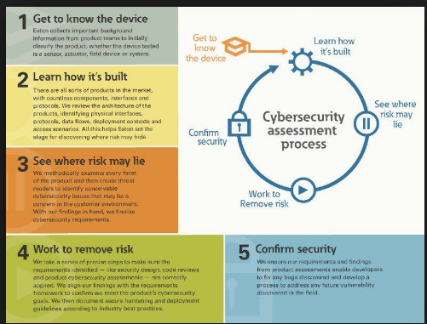
Saudi Electricity is additionally running its administrations on scrambled conventions "HTTPS" so the exchange and the information will be exchanged through the web as encoded information to maintain a strategic distance from any programmer's endeavors to peruse the information. The Encryption will be done through two encryption keys "Open and Private. The open key will be utilized for information encryption, and the private key will be used for information decryption. The public key will be used in the Saudi Electricity company side. The private key will be utilized in Saudi electricity's servers. In conjunction with such, there has been the following designed system
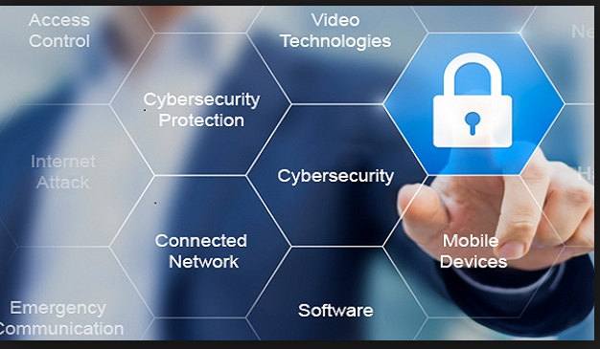
Owing to such, the company has dramatically secured the system's data through more of adjustments are needed due to technological changes witnessed daily. The changes are only made to suit technology and deter the exploitation of the previous system by the attackers.

Recommendations
We prescribe utilizing the examined cloud framework to keep away from abuse client information outside just as the maintenance of their center related to the company successful. So the information would not be revealed, and the client security will be kept up. In any case, this does not imply that the company needs to fabricate exorbitant server farm in its premises. The association can utilize national cloud server farm that is overseen by national ISPs. After this, Saudi electric association app and the database will be introduced on it. For this situation, the Saudi Electric enterprise can appreciate cloud administrations, for example, the application that can become to anyplace and whenever. Furthermore, Saudi electric company can keep up clients' information security.

Conclusion
From the analyses, it can be concluded that some investigation asserted that procedure approach ought not to be united with factor approach, this examination demonstrated that joining the two methodologies in a mixture approach is useful to see such a mind-boggling venture usage, for example, ERP framework. This exploration upheld a crossbreed approach that joined the factor and procedure approaches. While factor approach gave motivations to changing bookkeeper's observations towards ERP execution, the procedure approach gave proof into how such reasons vary after some time and nearby the usage procedure. In this way, joining the two methodologies gave all the more understanding and clarification of ERP usage. The half and half methodology gave increasingly powerful and vitality to consider the unpredictable circumstance. The procedures investigations uncovered a few likenesses and a few contracts that ought to be more clarified. The study of the three phases revealed that ERP execution stages are not steady and there are no sound stages that must be adjusted. Also, this examination bolstered the possibility that each organization ought to improve the usage arranges that fit its surroundings. The investigation uncovered that ERP execution stages distinguishing proof and definition would remain an exact one. The three cases studies have utilized clients, in this exploration case, bookkeeper's recognition for being a substantial measure for ERP usage procedure and result. These three recognitions are dynamic as they changed over the time of the usage arranges as they are impacted by certain necessary variables.

References
- Chiu, C. M., Wang, E. T., Fang, Y. H., & Huang, H. Y. (2014). Understanding customers' repeat purchase intentions in B2C e‐commerce: the roles of utilitarian value, hedonic value and perceived risk. Information Systems Journal, 24(1), 85-114.
- Harper, C. (2015). Organizations: Structures, processes and outcomes. Routledge.
- Monczka, R. M., Handfield, R. B., Giunipero, L. C., & Patterson, J. L. (2015). Purchasing and supply chain management. Cengage Learning.
- Niazi, M., Mahmood, S., Alshayeb, M., Riaz, M. R., Faisal, K., Cerpa, N., ... & Richardson, I. (2016). Challenges of project management in global software development: A client- vendor analysis. Information and Software Technology, 80, 1-19.
- Paluch, S., & Wünderlich, N. V. (2016). Contrasting risk perceptions of technology-based service innovations in inter-organizational settings. Journal of business Research, 69(7), 2424-2431.
- Se.com.sa. (2019). Saudi Electricity Company. [online] Available at: https://www.se.com.sa/en-us/Pages/home.aspx [Accessed 2 Apr. 2019].

